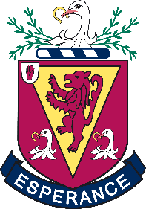
The Wallace High School Year 8 Induction Programme
A key component of our Year 8 pastoral programme is the Year 8 Induction Programme. This programme is designed to help support our new pupils and allow them the time to develop friendships and become more accustomed to life at Wallace. The programme is also developed to involve and inform our new Wallace parents of Life at Wallace. The programme commences in June of P7 and continues until the Christmas break in Year 8.
Year 8 are also supported throughout the school year by the Year 8 Pastoral Team, Year 8 Mentors (senior pupils who help our Year 8 settle at Wallace), a pastoral period one day a week, the Year 8 WHS Booklet and a whole host of more activities and events.
Below is an outline of what the Induction Programme entails:
- Year 8 Intake Day in June of P7
- Two half day induction days in August of Year 8
- Year 8 Parents’ Information Evening
- The Year 8 Adventure Day
- Year 8 Pastoral Interviews in October with Class Tutors and Form Staff
- House System, competitions, and House Quiz
- Year 8 Movie Night

