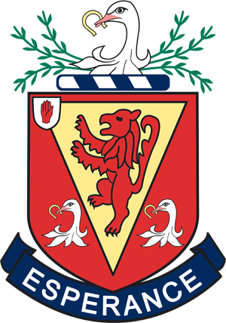

SCHOOL UNIFORM

YEARS 8 to 12

School Uniform is compulsory for all pupils during term time and at school functions outside normal school hours.

House colours are as follows:

Girls Boys

Gracey Green Conway

Hanna Red Barbour

Seymour Yellow Hamilton
- All items should be marked with the pupil’s name.
- Suppliers are not authorized to make changes to the uniform regulations.
- Please check before buying if you are not sure.

Advice on uniform is available from the school. Please note we are in a period of transition. Our school uniform suppliers will be selling the "new" style of school blazer (wool with braid trim) but pupils may still wear the "old " style blazer.

GIRLS' UNIFORM

School blazer (either "old" style or "new" wool blazer)

Regulation kick pleat grey skirt (to be purchased at below knee length)

White shirt (short sleeved white shirts may be worn at designated times)

School tie with House colour stripe

Regulation grey pullover with navy neckband stripes or school cardigan edged with navy

Regulation grey knee-length socks or opaque black tights

Plain black leather or leather substitute flat-heeled school shoes

(high-heeled fashion shoes, kitten heels and pumps are not permitted)

School scarf (for outdoor wear only - optional)

BOYS' UNIFORM

School blazer (either "old" style or "new" wool blazer)

Plain white shirt

School tie with House colour stripe

Charcoal grey trousers - plain

Grey V-neck pullover and dark grey socks

Flat-heeled, plain black leather or leather substitute shoes

School scarf (for outdoor wear only - optional)

SUPPLIERS:
R W McCall Warnock’s Reach E.P.S. Ltd
15 Market Street 791 Lisburn Road Lissue Industrial Estate [East]
Lisburn Belfast Moira Road

Lisburn

